FinSearch

- About The Initiative:-
- FinSearch is a research-driven program where the participating teams will be given a particular research project in finance with an expectation to promote financial research and enhance financial knowledge.
- Enrolled students would be participating in teams of 4. They can register in teams directly, and if they are unable to form teams, can register individually, in which case we will pair them up.
- Teams would be given an option to choose from a list of 10 topics to provide students an opportunity to get acquainted with the various exciting domains of the finance world.
- To create an efficient and effective learning environment for students, we are employing a mentor-mentee structure that will facilitate the students (mentees) endeavouring to learn about a particular financial topic to get assistance and guidance in the correct direction, with the help of students who are already indulged in that field and are acquainted with the jargons of it.

- Our Aim:-
Through this initiative, we intend to enrich the financial acumen of the enrolled students and try to incite an interest in them. After the completion of the FinSearch project, a student:-
- Would have a better understanding of the particular topic
- Would be capable and equipped enough to apply the concepts learned through this project to an existing real-life situation (refer to the flowchart below for better understanding).
*Let us assume a student has been assigned the topic: Is Value Investing Dead? For the completion of the project, the student will be expected to follow the following basic structure:-
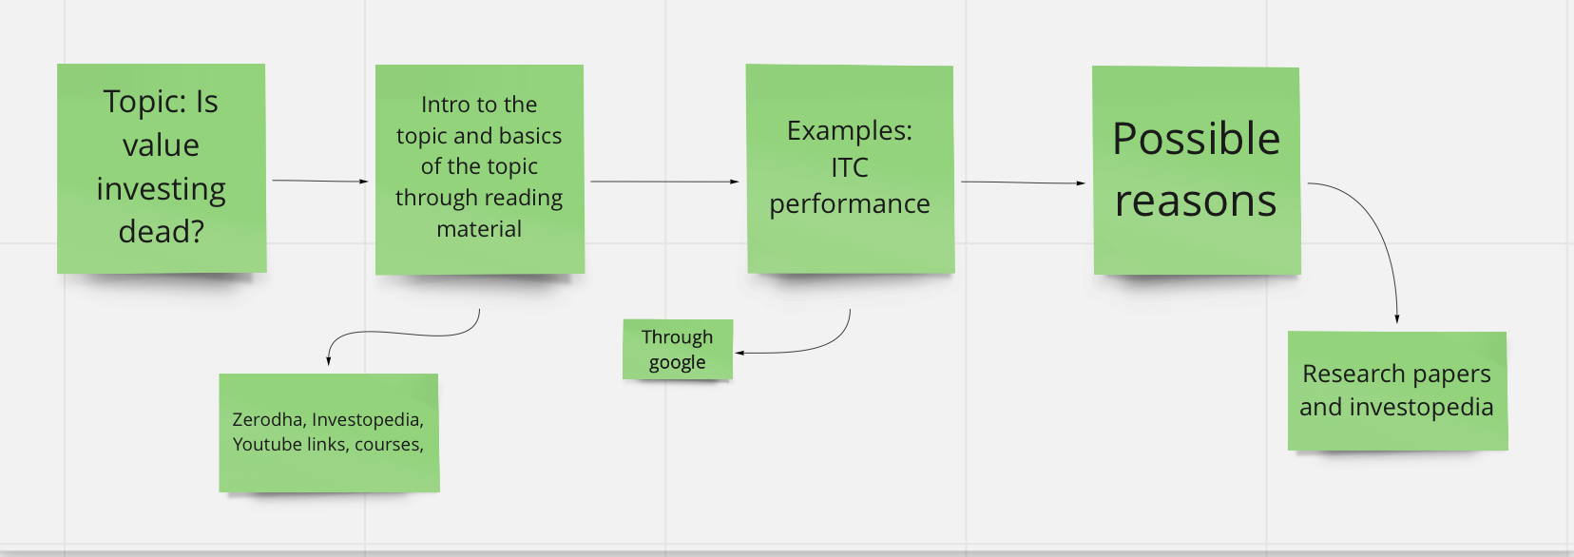
- Would be able to present their paper in front of a reviewing committee and defend their findings.
- Would be able to arrive at a final inference/ stand for the posed problem.

- The Mentor-Mentee Programme:-
- The mentors would possess a basic knowledge about the topic(s) under their purview.
- Mentors will act as the point of contact for the student and assist them in overcoming any obstacle that they might stumble upon along the course of their project.
- These mentors will also serve in the reviewing committee against which the groups would defend their final report. The Finance Club Council would supervise these mentors to ensure the smooth running of the system.

- Work:-
- Any project won’t take more than 3-4 hrs per week.
- You can do it along with ITSP/SOS/SOC/SURP or any other activity
- You would have to give weekly updates to the mentors
- A mid-term work report would be a submission of your work update till that time
- End term submission would be a PPT summarising your research

- Timeline (This is a tentative timeline):-
- 5th June - Launch of topics and mentor form.
- 10th June - Launch of mentee forms
- By 15th June, mentors and topics will be allotted to the teams
- The second week of July - Mid-term work report submission.
- The third week of August - End term work report submission along with final presentation(we will have intern season and end-sem exams for Freshies in our mind while setting up the last dates)

- Topics
- Understanding Trading of Currencies and Commodities in the Stock Market
- How Investment Biases Affect Investing Decisions
- How Bankruptcy, Insolvency, Mergers & Acquisitions Affect Stock Market
- Is Algorithmic Trading the Future of Trading?
- Option Pricing Models and Their Accuracy
- Using Machine Learning to Analyse News for Movement in Stock Prices
- Understanding the effects of interest hikes on stock, bond, and derivatives markets
- Understanding Credit Score Algorithms
- Early signs and prediction of bankruptcies
- Performance of Crypto Assets and understanding their volatility

